HelpDesk Pro – SQL Analysis Summary
Project: HelpDesk Pro – End-to-End Business Analysis of an IT Service Management System
Phase: Phase 4 – Data Analysis & Reporting
Tools Used: DB Browser for SQLite, SQL
Dataset: 100 simulated support tickets
Status: Draft – For Stakeholder Review

1. Objective
The objective of this analysis is to examine simulated support ticket data using SQL and generate insights that can help a Support Manager understand ticket status, priority distribution, agent workload, escalation activity, resolution time, and overdue tickets.

2. Dataset Overview
The dataset contains 100 simulated support tickets with information such as Ticket ID, Customer ID, Issue Category, Priority, Status, Assigned Agent, escalation details, creation date, due date, and resolution time.
The dataset is designed for portfolio demonstration and does not represent an actual company's operations.

3. SQL Queries and Results

3.1 Tickets by Status
Business Question: How many tickets are in each status?
SELECT
Status,
COUNT(*) AS Total_Tickets
FROM tickets
GROUP BY Status
ORDER BY Total_Tickets DESC;

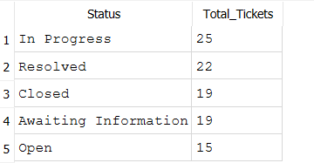

Results:Business Insight: In Progress is the largest status group, with 25 tickets. The Support Manager can review the active workload and determine whether any tickets need additional attention.

3.2 Tickets by Priority
Business Question: How are tickets distributed across priority levels?
SELECT
Priority,
COUNT(*) AS Total_Tickets
FROM tickets
GROUP BY Priority
ORDER BY Total_Tickets DESC;
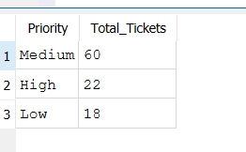

Results:Business Insight: Medium-priority tickets represent 60% of the dataset. The Support Manager should also monitor high-priority tickets to ensure urgent issues receive timely attention.

3.3 Agent Workload
Business Question: How many tickets are assigned to each support agent?
SELECT
Assigned_Agent,
COUNT(*) AS Total_Tickets
FROM tickets
GROUP BY Assigned_Agent
ORDER BY Total_Tickets DESC;
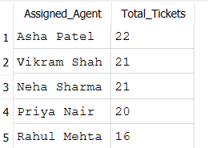

Results:Business Insight: Asha Patel has the highest number of assigned tickets, at 22, while Rahul Mehta has 16. The difference is six tickets. Workload fairness should also be assessed using ticket complexity, priority, and resolution time.

3.4 Escalation Distribution
Business Question: How many tickets have been escalated to the technical team?
SELECT
Is_Escalated,
COUNT(*) AS Total_Tickets
FROM tickets
GROUP BY Is_Escalated
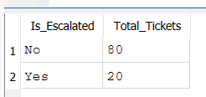
ORDER BY Total_Tickets DESC;

Results:Business Insight: Twenty tickets are marked as escalated. Further analysis by issue category and priority could help identify the types of issues that require additional technical assistance.

3.5 Average Resolution Time
Business Question: How long does the team take to resolve tickets on average?
SELECT
ROUND(AVG(Resolution_Time_Hours), 2)
AS Average_Resolution_Hours
FROM tickets
WHERE Resolution_Time_Hours IS NOT NULL;
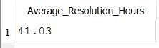
Business Insight: The average recorded resolution time is 41.03 elapsed hours. This metric can help management monitor resolution performance and identify areas for improvement. Comparisons against service targets require agreed resolution-time rules.

3.6 List Overdue Tickets
Business Question: Which unresolved tickets have passed their due dates?
SELECT
Ticket_ID,
Priority,
Status,
Assigned_Agent,
Due_Date
FROM tickets
WHERE Status IN ('Open', 'In Progress', 'Awaiting Information')
AND Due_Date < '2026-10-10 12:00'
ORDER BY Due_Date ASC;
Analysis: The query lists unresolved tickets whose due dates were earlier than the reporting cutoff of 10 October 2026 at 12:00 PM. The earliest due dates appear first.
Business Insight: The Support Manager can use this list to prioritize follow-ups and investigate delayed tickets, especially those with high priority.

3.7 Total Overdue Tickets
Business Question: How many unresolved tickets are overdue?
SELECT
COUNT(*) AS Total_Overdue_Tickets
FROM tickets
WHERE Status IN ('Open', 'In Progress', 'Awaiting Information')
AND Due_Date < '2026-10-10 12:00';
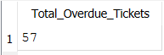
Business Insight: Under the illustrative due-date assumptions, 57 tickets were overdue at the reporting cutoff. This is a potential backlog that should be investigated in the simulated business scenario.

4. Key Findings
- In Progress is the largest status group, containing 25 tickets.
- Medium-priority tickets represent 60% of all tickets.
- Asha Patel has the highest assigned ticket count, at 22.
- Twenty tickets are marked as escalated.
- Average recorded resolution time is 41.03 hours.
- Fifty-seven unresolved tickets are overdue under the sample's illustrative deadline rules.

5. Business Recommendations
- Review tickets that remain In Progress and identify any blockers.
- Monitor high-priority tickets and ensure they receive appropriate attention.
- Evaluate agent workload using ticket counts, complexity, and resolution times.
- Investigate escalated tickets to identify recurring technical issues.
- Review overdue tickets and agree on an escalation or follow-up process.
- Establish and validate resolution-time targets before using these metrics to assess actual performance.

6. Assumptions and Limitations
- All ticket records are simulated for portfolio purposes.
- Due dates use illustrative targets of 24 hours for High priority, 72 hours for Medium priority, and 120 hours for Low priority.
- These targets are not approved business policies.
- Resolution time represents elapsed hours, not business hours.
- The overdue analysis uses 10 October 2026 at 12:00 PM as the reporting cutoff.
- Findings describe the sample dataset and must not be presented as evidence about a real company.

7. Conclusion
SQL was used to analyze ticket status, priority distribution, agent workload, escalation activity, average resolution time, and overdue tickets. The results demonstrate how a Business Analyst can turn structured data into useful operational insights and reporting requirements.
The next step is to visualize these metrics in Power BI and create an interactive dashboard for the Support Manager.
Document Status: Draft – For Stakeholder Review.

